# How to check-in source code with work item associated using Team Foundation Server API

## Introduction

This example shows how to check-in source code with work item associated using Team Foundation Server API. In this example, it also includes capturing possible exception and work item validate result.

## Prerequisites

1. ***Visual Studio 2015, Team Foundation Server 2015***
2. ***Add a user to the project team.***

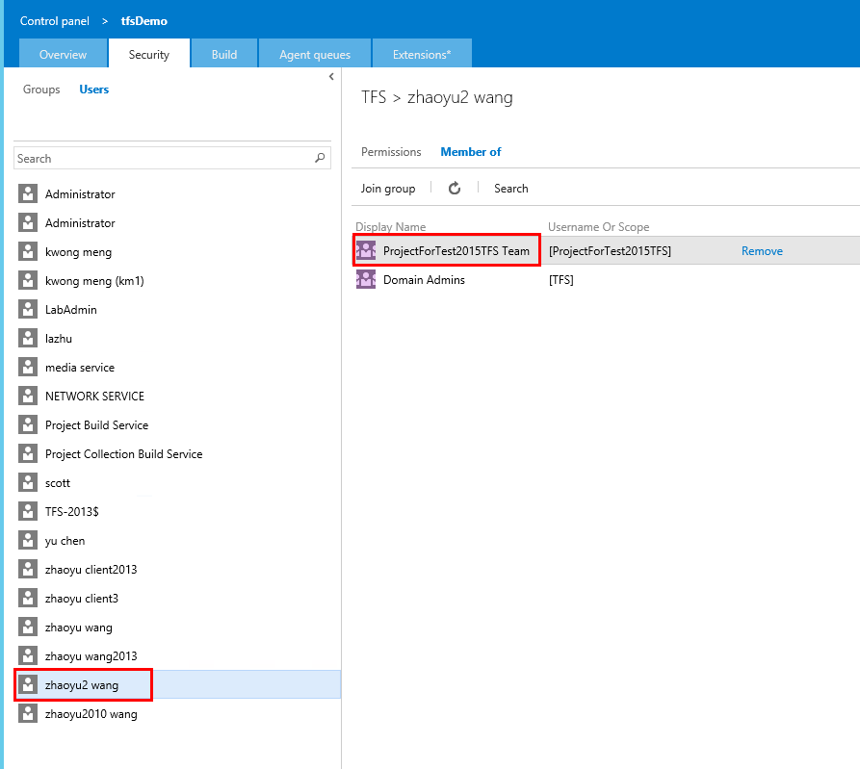

1. ***Connect to the Team Project and create a new workspace***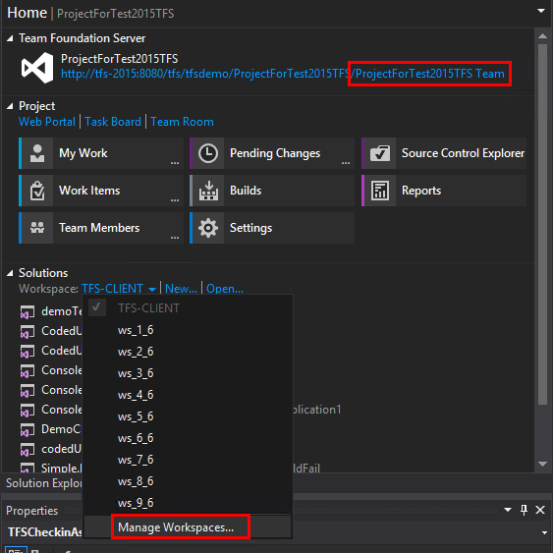
2. ***Map the server folder to a local path.***

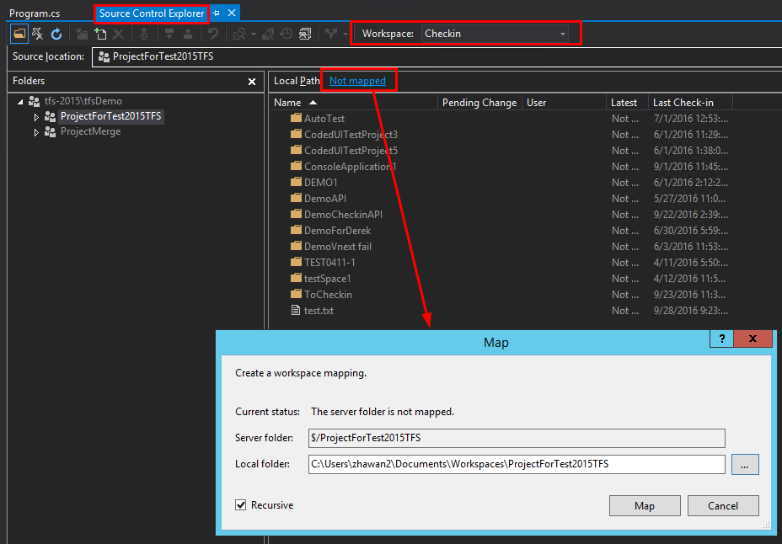

1. ***Check out a file for edit and modify this file in the mapped local path.***

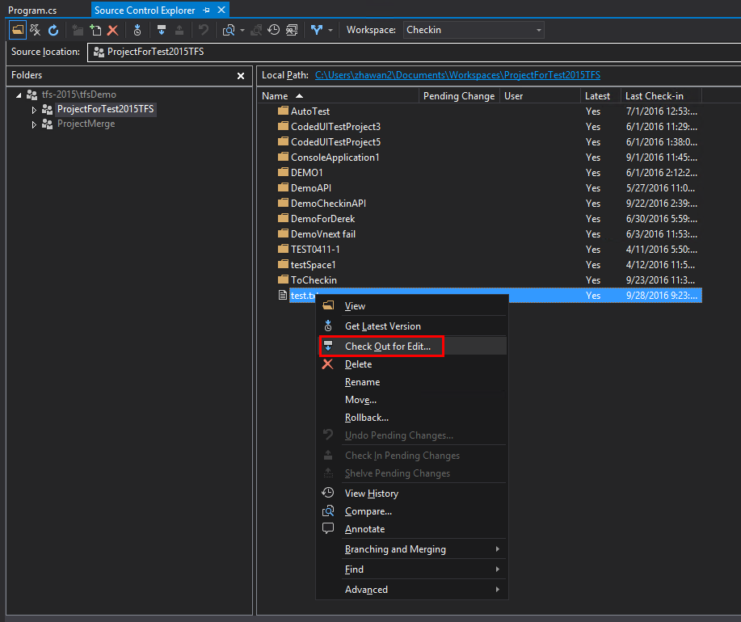 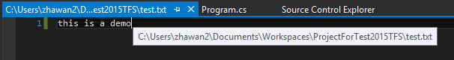

Please remember the workspace name and Local path, you will use the information in our project.

## Building the Sample

1. ***Open the sample solution in Visual Studio 2015.***
2. ***Initial following variables.*** 
   1. ***Collection URL***
   2. ***Workspace name***
   3. ***Work Item ID that need to be associated***
   4. ***Comment for check-in***
   5. ***Local path and name of the file that need to check-in***

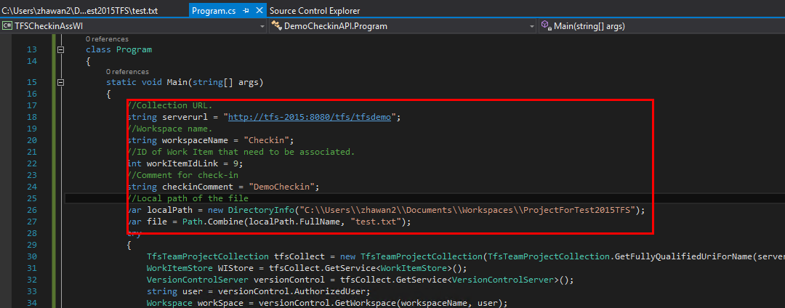

1. ***Make sure following three assembly have been successfully added.***

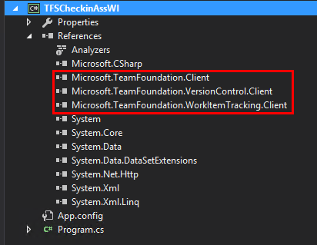

## Running the Sample

Click the “Start” button and begin debugging, you could also add breakpoints.

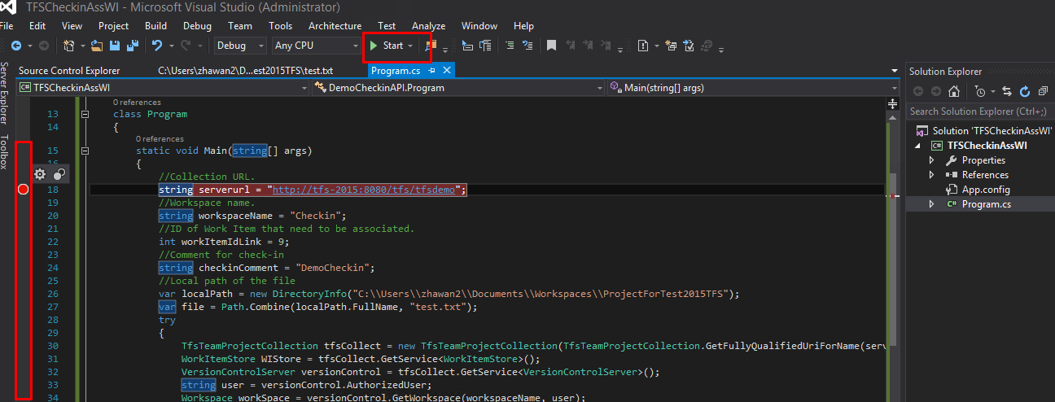

If Check-in succeeds with work item associated, you could see following information. Also, you could check the changeset and associated work item in TFS web portal.

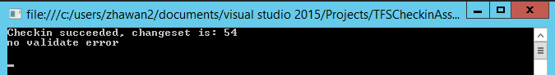

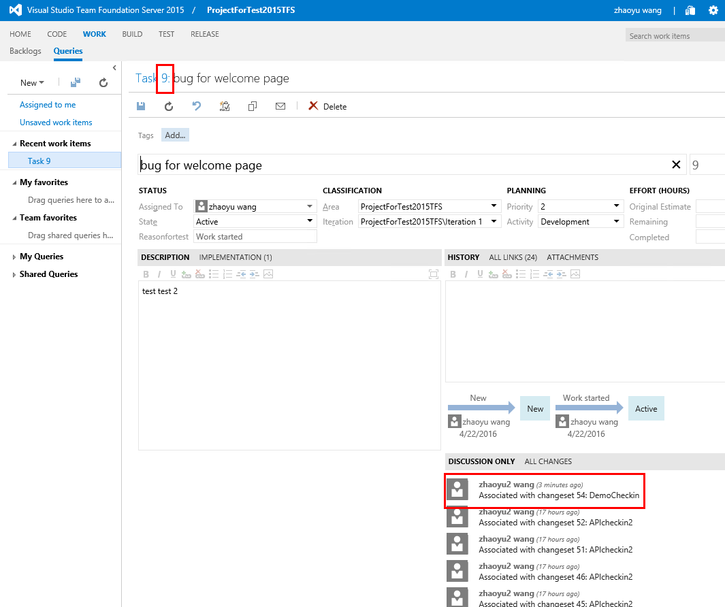

If exception happened, the exception message and stack trace will be saved in current temp folder. Also, you could directly check them in the console window.

